Jeffery Crosby
7-18-12
Mr. Cannon
BIOL 1010-001
SNAKE VENOM IN MEDICINE
Nature! Such a fantastic piece of art that gives true meaning and beauty to the planet, Earth. It holds many mysteries that are just waiting to be discovered by women and men all around the world to shed light on past findings or even provide new intelligence to make way for future work. The biggest part that has given much knowledge and products to benefit people is none other than “animals.” Animals are such an important aspect to people’s everyday lives by providing not just means of helping out the environment but even giving their necessities to be used in the development of many goods. None has made such a huger contribution to society than “snakes,” for the use of their venom in making medicine. It’s a wonder to people just what goes into the medication with the venom and how all the ingredients are provided, what makes the medicine work, and why it even benefits individuals across the globe. But, even those around the world give the means to make it beneficial.
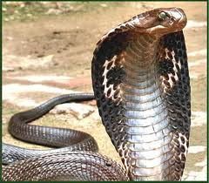
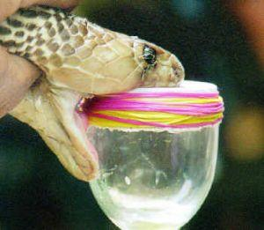
Snakes! One the most feared creatures by many around the world, including a lot of members in my family. Just the sight of one (poisonous or nonpoisonous) is enough to make my mom back away and not do anything until it’s slithered away. There are 3,400 known species of snakes and a quarter of them are venomous which include: cobras, rattlesnakes, vipers, sea snakes, and more. (Wikipedia, Snakes) Just how many deaths take place from snake bites though? According to the University of Florida, not many deaths occur each year from being bitten by a venomous snake in the U.S. because of the means for treatment. (UF Wildlife – Johnson Lab) Even though snakes have a dangerous tool against humans, venom, it is however used in the production of medicine to help women and men. But how is the venom provided in the creation of medications? Snake venom is extracted through special facilities, such as the Natural Toxins Research Center, which then sends it out to scientists for study and creation to help in like heart attacks and cancer. (Making Medicines from Poisonous Snakes) The mystery behind snake venom and its chemical make-up is seriously curious but not anymore.
King Cobra (Most Venomous Snake In the World)
Wildlife is so fascinating that each species is different in its own way. Animals have their unique ways to track, survive, and defend themselves in the wild. Take for example, wolves who travel in packs to locate their prey and watch out for one another; the platypus (in Australia) which uses its bill to help it see around in the water when searching for food; or snakes which use their tongues to locate food and sink their fangs to strike at foes who dare to approach them and not back off. Each of these creatures is adaptive to their environment and has developed their own means of survival so that they can be able to stay in existence for future generations. While wolves use each other for means of protection, snakes have their venom in order to cause drastic illness to their victims.
Milking of a Venomous Snake
According to scientists, snake venom comes in two variations which are neurotoxic (paralysis and death) and hemotoxic (sickness), but, this is all due to the maturity of snake. It’s said that the smaller the snake, the less venom there is to cause death; while the bigger ones seem to have much danger to mankind. (Venom Composition & Production) People see snakes as a threat and that their venom is nothing that can be of any help, but in retrospect, there’s more to it than meets the eye. Just what exactly makes the venom so unique? Snake venom is said to contain many proteins such as enzymes and polypeptides which means that they help with people’s health to keep them healthy and running for a time. (Venom Composition & Production) With the presence of enzymes this will allow the speed up of a person’s blood so that it can flow steadily and keeps the body functioning. Just like enzymes, which are proteins, polypeptides contain many amino acids which contain much of the essential elements to life which include hydrogen, carbon, oxygen, and nitrogen; because of this it means that humans are getting the proper nutrition to sustain one’s self and stay living. (Concepts of Biology, Pgs. 53,90) But, besides helping in health, snake venom is more beneficial in so many ways.
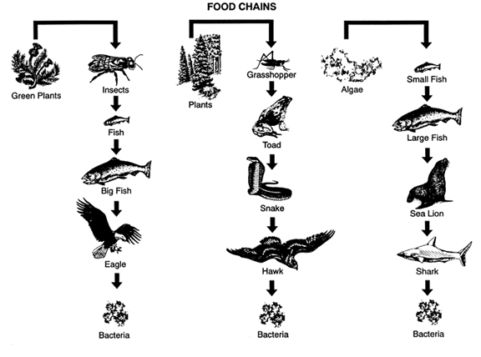
In every known country on Earth, creatures have become such a big part of the natural environment by providing services to make it better. Take for example those animals that eat the remains of dead wildlife, such as vultures or Tasmanian devils, but what they’re actually doing is cleaning up germs, diseases, and sickness so that other animals don’t come to harm. Then think about the food chain. From the lower levels which include plants and insects; to the upper levels involving predators like wild cats and birds of prey; each level is important as progress is made like grass is eaten by bugs, which they benefit fish or mice, and finally comes snakes and eagles (eat snakes). Snakes, venomous ones, on the other hand give something more to the world which is the means of medicine.
Each day, hundreds of people are diagnosed with some kind of disease or sickness that is very fatal such as west nile virus, cancer, diabetes, and more. So, as a result, they are required and must take medication in order to sustain their internal systems for more time to live in the future. Medicines are manufactured from the combination of many ingredients in order to allow the pill to work for the right reason, but, what some people don’t realize is that one ingredient used in medication production is “snake venom.” Venom has gone into the creation for situations such as heart attack, stroke, and cancer. Snake venom as has been pointed out, contains proteins which help metabolize the internal systems and this benefits to help in the health and living of those who have serious medical situations. (Making Medicines Poisonous Snakes)
The world has so much to offer in many ways but none has done a better job than the natural world. Animals have provided so much for Earth’s inhabitants by means of food, clothing, and even medicine. The one species though has offered a great deal for people on each continent is serpentines, or snakes, venomous snakes. Snake venom as many don’t know contains proteins such as enzymes and polypeptides in order to give the proper health to sick individuals that could eventually die in the near future. Many medications have been created that include snake venom for situations such as heart attack, stroke, and more which shows that scientists are making great strides in order to keep people living for a longer period of time. It even demonstrates that there are other possibilities for more work and discovery to be made in helping with other serious illnesses. Let’s never forget the contribution that snakes have provided in order to sustain our lives and may they be honored, FOREVER!
WORKS CITED
- http://en.wikipedia.org/wiki/Venomous_snake
- http://en.wikipedia.org/wiki/Snake
- http://ufwildlife.ifas.ufl.edu/venomous_snake_faqs.shtml
- http://science.education.nih.gov/animalresearch.nsf/Story1/Making+Medicines+from+Poisonous+Snakes
- http://www.bio.davidson.edu/people/midorcas/animalphysiology/websites/2008/Eskew/Composition.htm
- Concepts of Biology SECOND EDITION, Sylvia S. Mader; Pg. 53, 90

